Chapter 1

# **1.1 Introduction**

Web applications or "web apps" are software programs that run on a web server. They consist of diverse components including traditional and nontraditional software, interpreted scripting languages, plain hypertext markup language (HTML) files, mixtures of HTML and programs, databases, graphical images, and complex user interfaces. [1] A web application is available anywhere a connection to the internet is found. This means a web application is not tied to a specific computer like a traditional software application, allowing for more accessibility and ease of use. The user experience tends to be more consistent with a web application, because user data is processed and stored on the server and the graphical user interface (GUI) is dependent on the web browser.

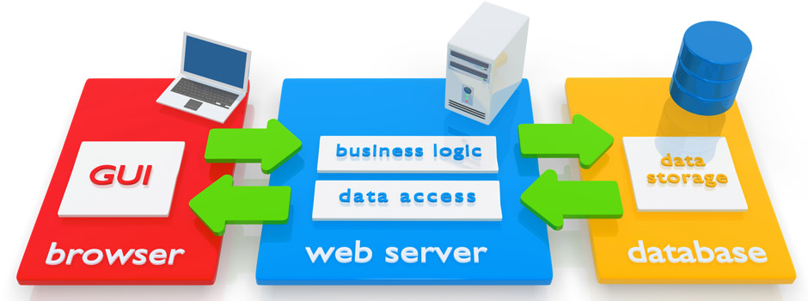

Figure 1.1 - Simple Web Application Diagram by vTech Solution Inc.

The tremendous reach of Web applications into all areas of communication and commerce makes this one of the largest and most important parts of the software industry. [1] Many software companies now offer both desktop and web versions of their most popular programs. Common examples include Microsoft Office, Apple iWork, and Intuit TurboTax. In most cases, files saved in the online version are compatible with the desktop version and vice versa. For example, if you save a.TAX2013 file in TurboTax Online, you can open and edit the file with the desktop version. [2]

# **1.2 Application**

For my project, I decided to create a web application. My application will be a project portal for teams working on various projects at the Department of Natural Resources (DNR). Each project will have its own project portal and will consist of three main pages. One Page will have a map of the project area and the map will have the ability to change which layers are visible to the user. Another page will have a calendar object that will contain the project related activities and meetings. The final page will contain a file browsing object that will display a file location on the server that holds project related files.

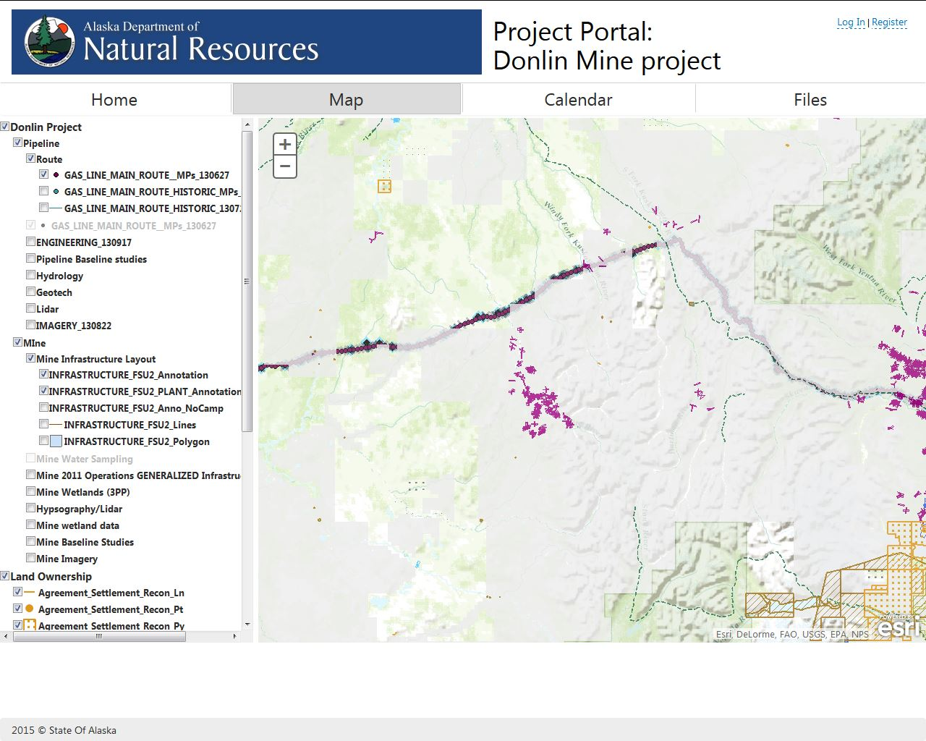

Figure 1.2 – Sample Image of What Maps Page Would Look Like.

A web application can be created using a number of different languages and technologies. The project portal will be primarily built using ASP.NET and C# for server side code. HTML and JavaScript will be utilized to perform client side page rendering services. The file browser and calendar will use third-party libraries from DevExpress.

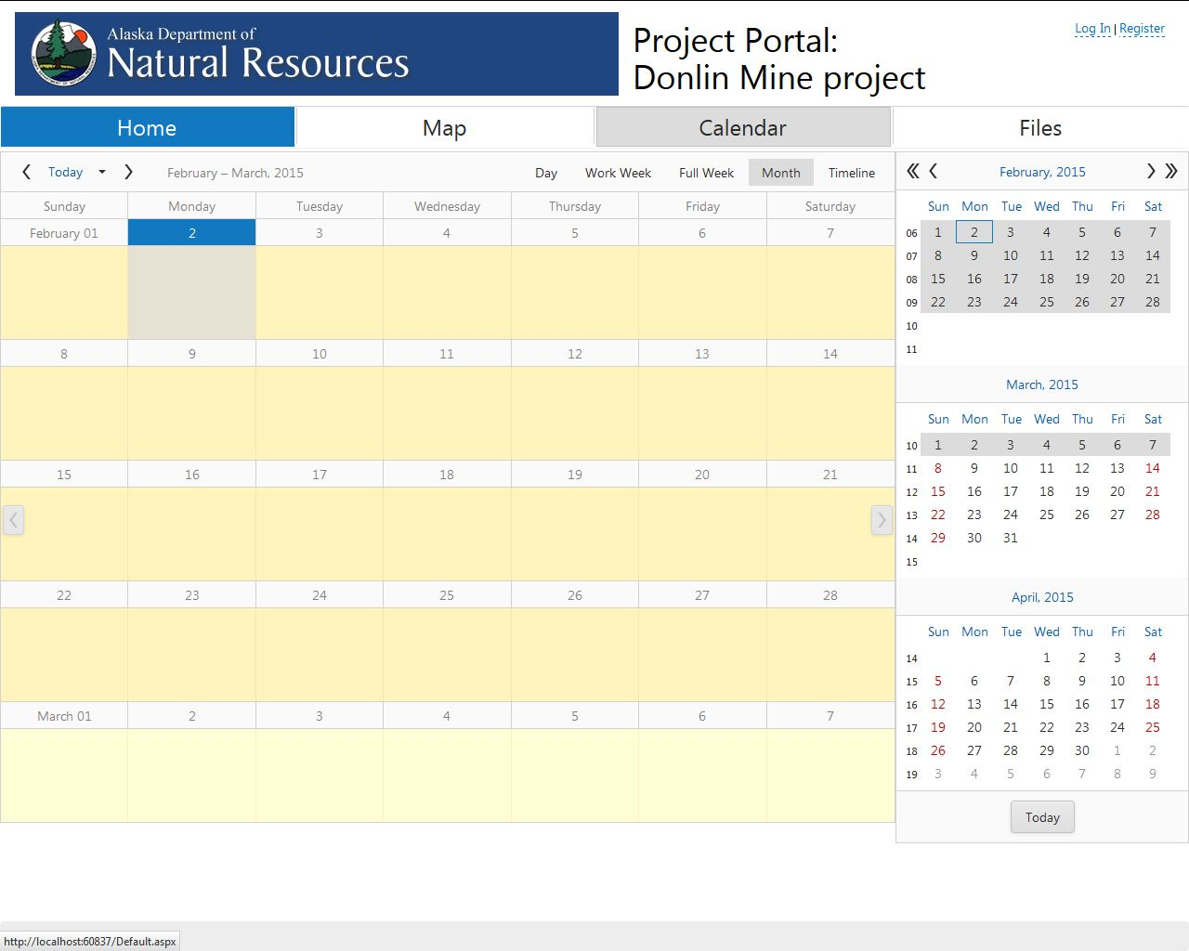Figure 1.3 – Sample Image of What Calendar Page Would Look Like.

Security requirements can be summarized in two sentences:

* Information should be disclosed only to those meant to see it.
* Actions should be performed only by those authorized to perform them.

Sound simple? So why, with such straightforward goals, is network security deemed one of the tougher areas of computer science? The difficulty lies in the very nature of the goals we’ve defined. While other areas of computer science aim to enable a certain feature, security is the art of prohibiting unauthorized individuals from reaching beyond the permissions they have been granted. All possible attacks must be considered, analyzed, and prevented. [3] The project portal will utilize user login authentication to provide a minimum level of security. This could be upgraded in the future to use the lightweight directory access protocol (LDAP) user credentials that already exist within the State of Alaska system.

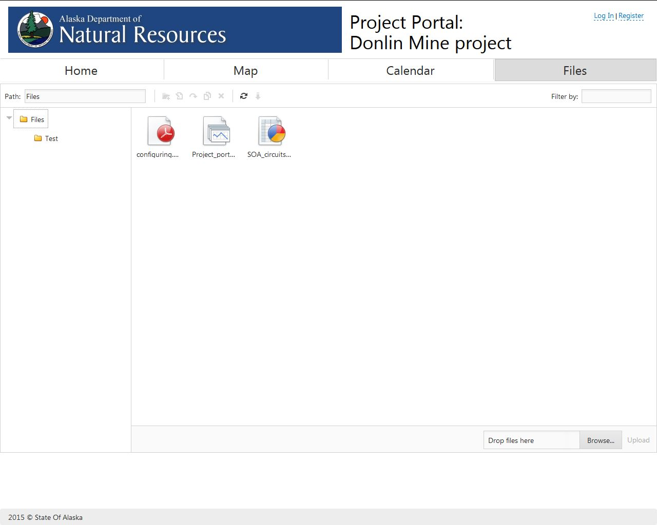

Figure 1.4 – Sample Image of What Files Page Would Look Like.

In Anchorage, .NET is the preferred language for websites and web applications.According to GeoNorth, an Anchorage software development company: .NET is one of the development languages of choice for high usage sites and sites with complex business rules and workflows.  Because it is a compiled language, it can be many times faster than PHP, ColdFusion, or other languages. You may have also heard of ASP.NET, which is the 'web design' portion of .NET, and works in conjunction with C# or VB.NET. If you want a fast site that can scale, or if you have complex business rules that need a lot of CPU power behind them, .NET is the way to go. Many of our Anchorage clients in Alaska use .NET, and we have deployed enterprise solutions as well as small websites and even handheld applications. [4]

# **1.3 Motivation**

My primary motivation comes from the fact that I am currently employed at DNR and my department manager asked me if I wanted to do this project. I really wanted to do a project that was going to be very practical and this project allows me to do just that. The project portal is likely to be implemented within the DNR system shortly after its completion and thorough testing. Working with DNR on this project gives me greater access to resources and a knowledge base that would not be available to me otherwise. Doing this project for DNR also gives me the opportunity to work on the project while at work, allowing me to better use my time.

My secondary motivation for wanting to do this project was because my department manager wanted the project done in .NET. I have not used .NET before and am unfamiliar with its features. .NET seems to be used almost exclusively here in Anchorage. Therefore it was important to me to learn how to use it in order to increase my job marketability. Creating web applications is one of the things I am interested in doing for a job, thus being able to put a project like this within my portfolio was very compelling for me.

# **1.4 Recent Developments**

# **References**

|  |  |
| --- | --- |
| [1] | J. Offutt, "Quality Attributes of Web Software Applications," *IEEE Software,* pp. 25-32, 2002. |
| [2] | P. Christensson, "Web Application Definition," 17 February 2014. [Online]. Available: http://techterms.com/definition/web_application. [Accessed 30 January 2015]. |
| [3] | B. Adida, "Securing The Web," *IEEE Internet Computing,* vol. 1, no. 4, pp. 91-93, 1997. |
| [4] | GeoNorth, ".Net Development in Anchorage," GeoNorth, [Online]. Available: http://www.geonorth.com/development/net/anchorage. [Accessed 2 2 2015]. |

Contents

**1.1 Introduction** 1

**1.2 Application** 2

**1.3 Motivation** 5

**1.4 Recent Developments** 5

**References** 6